Step 1.
Visit https://www.onexamination.com/products/international-medical-student-years-1-to-3 for the years 1 to 3 option.
or
Visit https://www.onexamination.com/products/international-medical-student-years-4-to-5 for years 4 to 5.
Step 2.
Select the 3 month option for the resource you require.
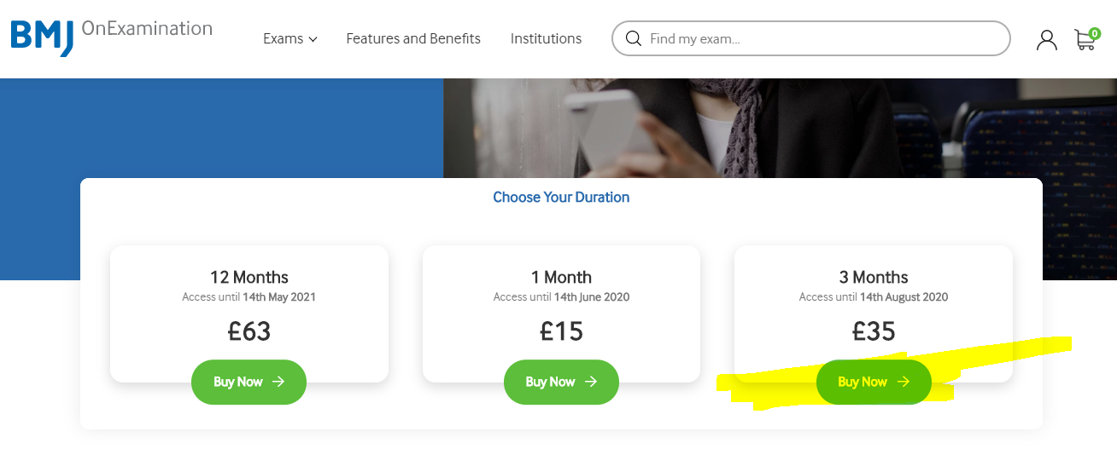
Step 3.
Your cart will be displayed and you’ll be prompted to ‘Go to Secure Checkout’.
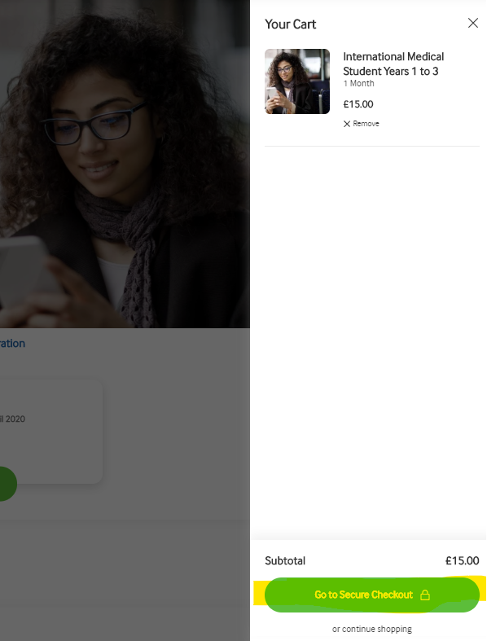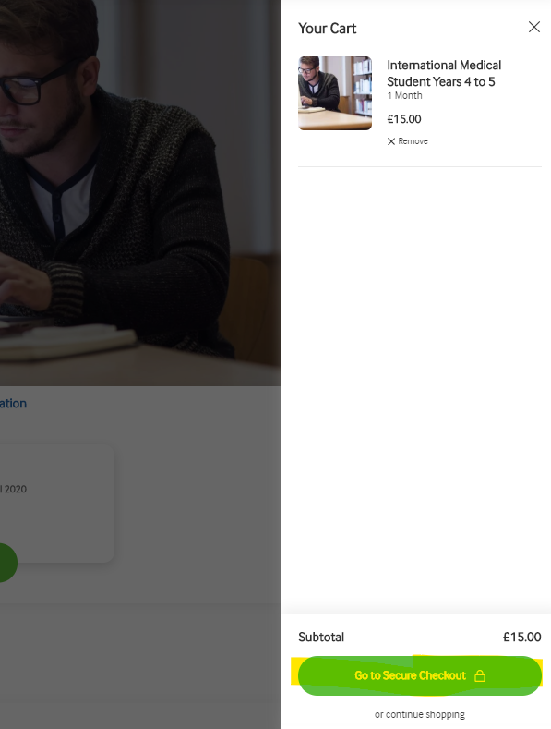

Step 4.
Enter your email address and billing address (you will not need to enter any payment information). Enter your OnExamination code in the box labelled Torostrial and click ‘Apply’.
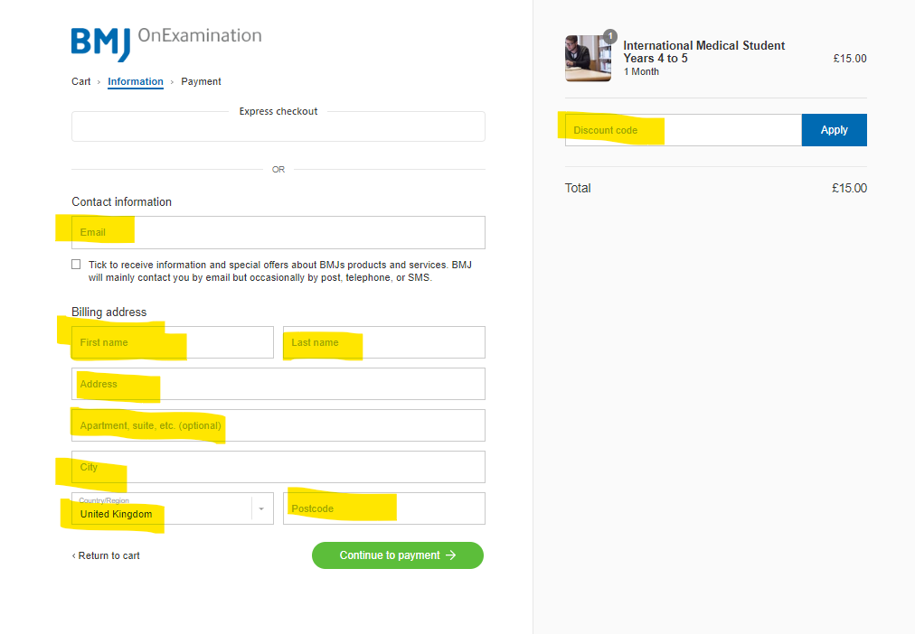
Step 5.
The £15.00 fee will be changed to £0 and your discount will be applied. 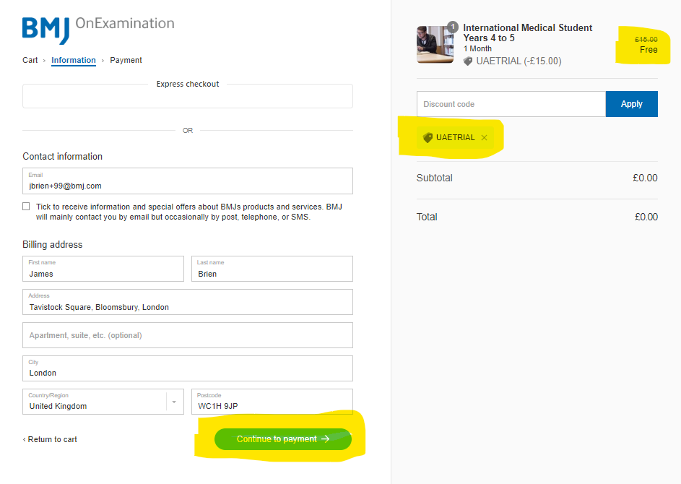

Step 6.
After clicking ‘Continue to payment’ as highlighted in the above screenshot, you’ll notice that the payment box says, ‘Your order is free. No payment is required’.
You can then click, ‘Pay now’ to complete the process.
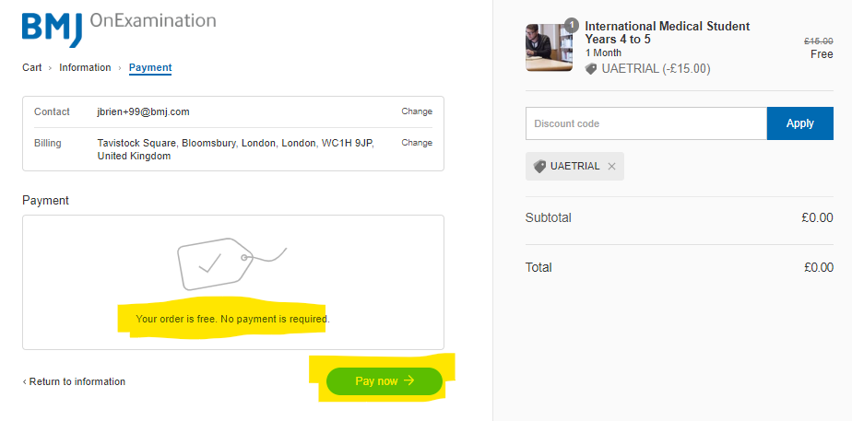
Step 7.
Your order has been confirmed, you’ll receive an email confirmation shortly.
